Ex.no:3 | DATA CLEANING

Aim:
To clean and preprocess the Google Play Store dataset by identifying and handling missing values, removing duplicate and blank records, correcting data types, and preparing a consistent and reliable dataset for further exploratory data analysis and application performance analysis.
Algorithm:
Check Missing Values
- Start.
- Import the Pandas library.
- Load the Google Play Store dataset into a DataFrame (df).
- Display the dataset information using df.info().
- Check for missing values using df.isnull().
- Count missing values in each column using df.isnull().sum().
- Check missing values using df.isna().
- Check non-missing values using df.notnull().
- Display the missing-value results.
Drop Missing Values
- Start.
- Import the Pandas library.
- Load the Google Play Store dataset into a DataFrame (df).
- Drop rows containing missing values using dropna().
- Use axis=0 to remove rows or axis=1 to remove columns.
- Use how='any' to remove rows or columns containing any missing value.
- Use how='all' to remove rows or columns only when all values are missing.
- Use thresh=N to retain rows or columns with at least N non-missing values.
- Use subset=['column_name'] to remove rows based on specific columns.
- Use inplace=True to modify the original DataFrame.
- Display the cleaned Google Play Store dataset.

Program:
import pandas as pd
import numpy as np
from google.colab import files

uploaded = files.upload()

csv_file = list(uploaded.keys())[0]

print("Uploaded File:")
print(csv_file)

df = pd.read_csv(
csv_file,
encoding="latin1",
low_memory=False
)

print("\nDataset Loaded Successfully")

print("\nOriginal DataFrame:")
display(df.head())

print("\n1. First 5 rows (head):")
display(df.head())

print("\n2. Last 2 rows (tail):")
display(df.tail(2))

print("\n3. Shape (rows, columns):")
print(df.shape)

print("\n4. Column Names:")
print(df.columns)

print("\n5. DataFrame Information:")
df.info()

print("\n6. Statistical Summary:")
display(df.describe())

print("\n7. Missing Values:")
display(df.isnull().sum())

print("\n8. Missing Values using isna():")
display(df.isna().sum())

print("\n9. Non-Missing Values:")
display(df.notnull().sum())

print("\n10. Duplicate Rows:")
print(df.duplicated().sum())

df = df.dropna(how="all")

df = df.drop_duplicates()

print("\n11. Dataset after removing blank rows and duplicates:")
print(df.shape)

print("\n12. Applications with Rating greater than 4.5:")

display(
df[df["Rating"] > 4.5][
[
"App",
"Category",
"Rating",
"Reviews",
"Installs"
]
].head()
)

print("\n13. Top Applications based on Reviews:")

display(
df[
[
"App",
"Rating",
"Reviews",
"Installs"
]
]
.sort_values(
"Reviews",
ascending=False
)
.head()
)

print("\n14. Category-wise Applications:")

if "Category" in df.columns:
display(
df["Category"]
.value_counts()
.head(10)
)
else:
category_columns = [
col for col in df.columns
if col.startswith("Category_")
]

if category_columns:
df["Category"] = (
df[category_columns]
.idxmax(axis=1)
.str.replace(
"Category_",
"",
regex=False
)
)

display(
df["Category"]
.value_counts()
.head(10)
)

print("\n15. Data Types after Cleaning:")
print(df.dtypes)

print("\nGoogle Play Store dataset cleaning completed successfully.")
Output:
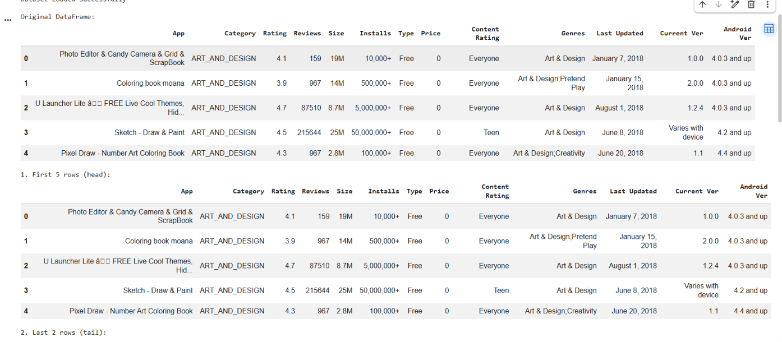
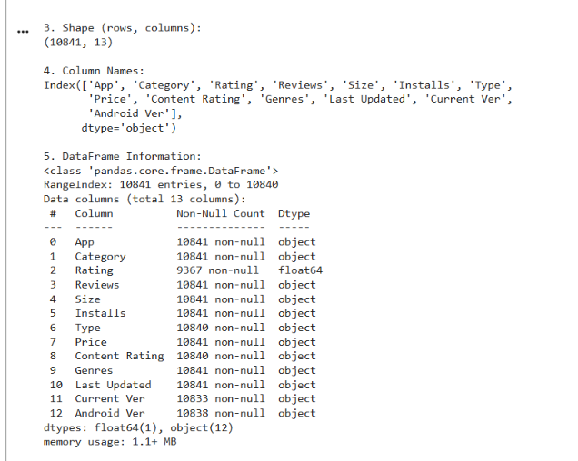
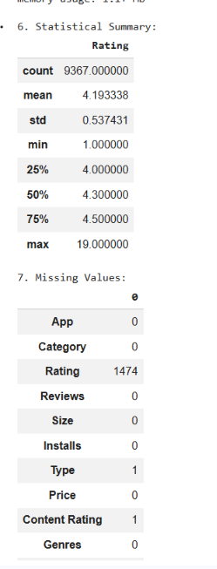
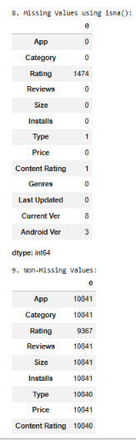
Result:

